

**DEPARTMENT OF MECHANICAL AND MANUFACTURIMG ENGINEERING**

**FACULTY OF ENGINEERING**

**UNIVERSITY OF RUHUNA**

INDUSTRIAL TRAINING REPORT SUBMITTED IN PARTIAL FULFILMENT OF THE DEGREE OF THE BACHOLAR OF THE SCEINCE OF ENGINEERING 2020

**CEYLON BISCUITS LIMITED**

**MAKUMBURA, PANNIPITIYA**

**(09/10/2023 to 31/12/2023)**

**RAJARATHNA W.M.C.S (RU/E/2020/4138)**

# Chapter01- Introduction of the Training Establishment

## History of The Training Establishment

The beginning of the most trusted food and beverage company in sri lanka was in year 1968. CARE organization of USA and the government of sri lanka entrusted Ceylon Biscuits Limited to manufacture a high protein biscuit to supplement the mid-day meal of school children. This project is based on a proposal by Mr.Mineka Wickramasingha, current Group Chairman, to improve the nutritional standard of Sri Lankan children. For this purpose a biscuit factory was built in pannipitiya area.

In the 1980’s company ventured aggressively into commercial operations and recorded one of the highest growth rates in any industry in Sri Lanka. Ceylon Biscuits Limited throughout invented new products for the market such as cookies, coconut crunch, ginger nuts and savory nuts etc. The group’s innovative product range, high focus on research and development, high quality standards and aggressive marketing strategies have allowed many of CBL’s brands to become market leaders in their respective categories.

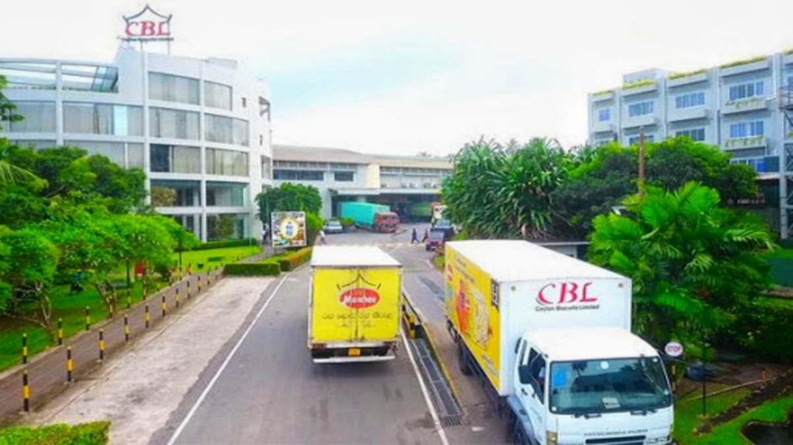

Figure 1.1: CBL factory premises

(Source: https://cbllk.com)



Figure 1.2: Logo of the company

(Source: https://cbllk.com)

## Current Situation of The Company

Today “Munchee” became a household name with over 60% market share against other competitors of their stream. And also gathering momentum in other countries and emerging as a market leader exporting over 45 international destinations including, United States, Canada, Australia, Fiji, New Zealand, UK, Trinidad, Ghana, Gambia, Bostwana, Hong Kong, China, India and several countries in Middle East. CBL have 9 biscuits manufacturing lines comprising of machinery from Europe and USA: manufacturing approximately 50,000 metric tons per annum and their factory area is over 12,000 square meters.

## Vision of CBL

“To be the No 01 Confectionary and Biscuit brand in Asia with a global presence and Recognition.”

## Mission of CBL

* Win with customers - ensure consumer and trade satisfaction by manufacturing products of highest quality
* Win with people - be a prestigious employer of a loyal and dedicated work force
* Win with shareholder - higher return on investment
* Win with public- socially responsible by having Eco friendly process and contributing towards the uplift of the society.

## Organization Details

Name: Ceylon Biscuits Limited

Address: No. 555, Highlevel Road Makumbura Pannipitiya.

Contact No: 076 660 0147 (Uday Kumara-Mechanical Engineer)

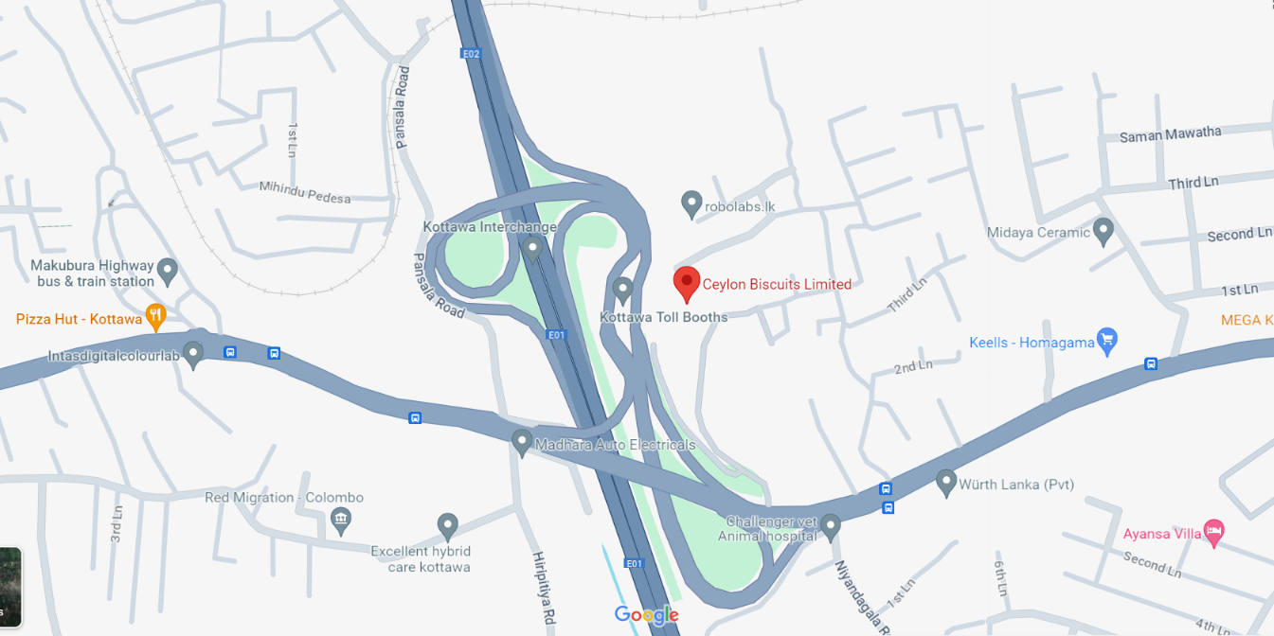

Figure 1.3:Company Location on Map

(Source: https://www.google.com/maps)

## Organizational Structure and Hierarchical Levels

Ceylon Biscuits Limited is well structured organization and responsibilities and tasks are split and given to different departments, each and every department has a general manger who responsible for the operational duties. Top management is done by the Board of Directors. Current Board of Director can be listed as below.

Chairman – Mr. Ramya Wickramasingha

Director Finance – Mr. Mahen De Saram

Director Engineering & IT – Mr. Rasith Wickramasingha

Managing Director – Mrs Sheamalee Wickramasingha

Director – Mrs Nishka Wickramasingha, Mr. Lakshman de Silva, Mr. Ranjith Fernando, Mr. Jayampathi Bandaranayake



## Hierarchical Levels of CBL Company



Figure 1.4: Hierarchical levels of CBL company

## Hierarchical Levels of Engineering Department

Figure 1.5: Hierarchical levels of engineering department

## Training Establishment’s Present Performance, Strengths and Weaknesses.

### Strength

## Ceylon Biscuits Limited is the market leaders in most of the categories that they operate in. Especially in biscuits industry they are well ahead than the other competitors. CBL is one of the fastest growing FMCG companies in Sri Lanka. They are very strong in research and development area and introduce innovative food products to Sri Lankan and international market. Ceylon Biscuits Limited is a family-based company leading by a well experienced business family. Strong partnerships and connectivity among board of committee members is the main reason for the success of the company.

## CBL is driven by talented and well-trained employees. They have bonded with the company by their heart. Location of the establishment is another reason for the strength of CBL. It is situated near by main entrance of recently developed ‘southern highway’ and ‘katunayaka highway’. It is a very good advantage for the company to distribute their products throughout the country.

## CBL takes its CSR efforts serious and has conducted many a national level and community level programs and schemes to support the varied requirements and groups. Munchee brand became the most trusted brand name among the Sri Lankan society through their CSR efforts in many areas including education, arts & culture, sports, communality development and corporate philanthropy.

### Weaknesses

Excess workforce and less technical update is one of the main weaknesses that I have seen in the company. World biscuit industry grew up rapidly in past decade using high technical devices and automation systems to increase their production efficiency. But Ceylon Biscuits Limited still using lots of conventional processes with lots of human efforts. Except 2 plants out of 8, still they are using old fashion machinery and equipment.

Work load distribution among the workers is less efficient, especially in maintenance department. Some mechanics have lots of works that they cannot manage with their time and some mechanics have very few works and they are wasting their time.

# Training Experiences – Technical

## Engineering Department

Among the all departments in Ceylon Biscuits Ltd, Engineering department plays a major role in technical field. All the maintenances, upgrades are done under the supervision of engineering department.

There are Three main sub fields in engineering department. They are,

* Mechanical
* Electrical
* Civil

Engineering department can be divided into two main parties by their responsibilities. They are,

* Management, Project design and documentation responsibilities
* Worksite responsibilities.

Management and design responsibilities are assigned to executive level engineers. They interact with other departments as well. Worksite responsibilities are assigned to technicians and they are under the supervision of technical supervisors. Usually projects are done by outside contractors.

## Production Process

Biscuits manufacturing process at CBL can be divided into major steps as follows.

### Flour handling system

Biscuits are made from dough with specific compositions like wheat flour, sugar, milk powder, malt, salt and other chemicals. Except these ingredients considerable amount of crushed biscuits powder added to the mixing bowl. But wheat flour can be considered as the main composition of a biscuit. For a continuous production, there should be a proper storing and supplying system of this main ingredient.The wheat flour is supplied by a local importer as 50kg bags or 40 ton containers. In order to speed up the process of loading a mixer and reduce the hard work involved, CBL using bulk flour handling system. In this system flour is stored in large containers called ‘silos.

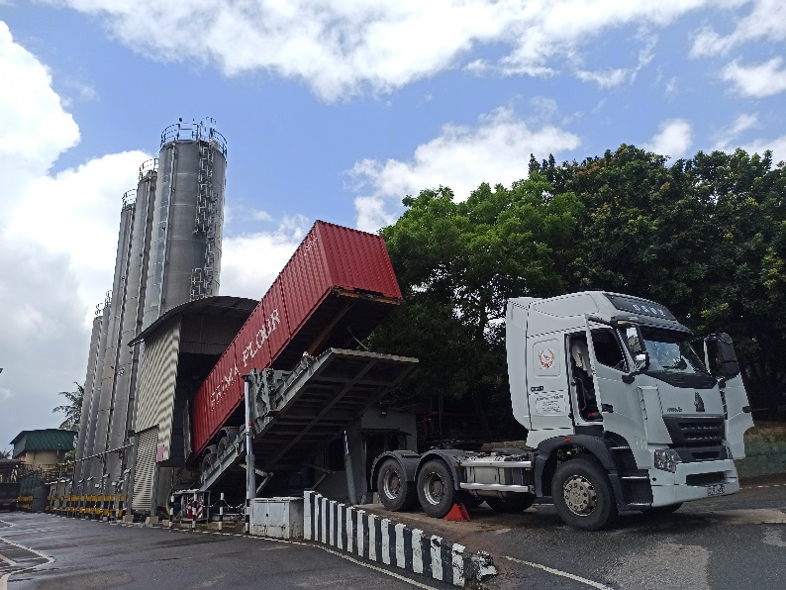

Figure 2.1:Flour handling system

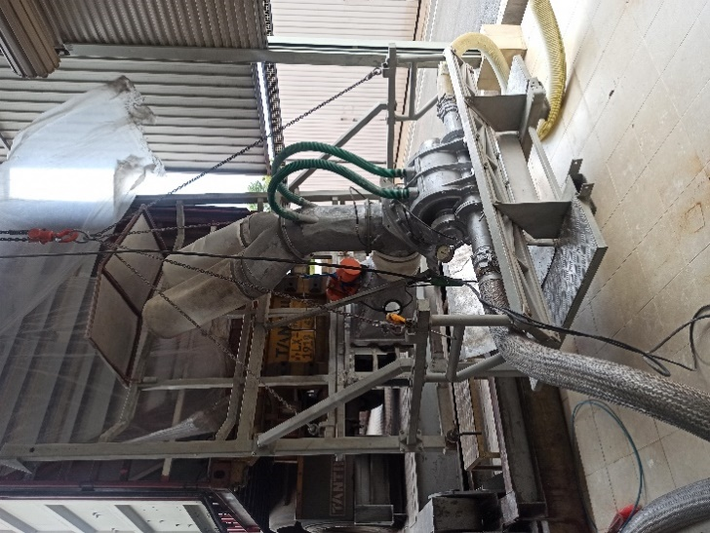There are five silos inside the factory. Three of them have 110,000kg capacity in each silo and other two have 25,000kg capacity. Flour handling system contains several units and components, (Ramp, Hydraulic Unit, Flour Unloading Unit, Rotary Valve, Vibration Motor,Filters,Pneumatic Lines,Blower,Flexible Pipes,Silo,Silo filters, Silo pressure relief valve,Sensors.Screw conveyer)

Figure 2.2:Flour Unloading Unit

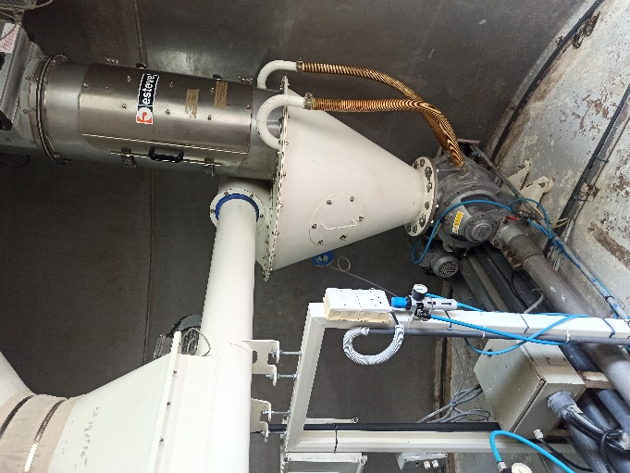

Figure 2.3:Flour distribution system

There is an electrically operated semi-automated flour distribution system to distribute the flour from these silos to each mixer. This system is called flour handling system (FHS) which contains several mechanical components like dehumidifiers, blowers, rotary valves, shifters and diverter valves. On top of each mixer there is a sending tank which collects the required amount (weight) of flour from flour handling system.

After collecting required amount of flour and other compositions it sends into the mixer. There are small two blenders with electric motor and beater attachment to beat and pour salt and east into the mixer

### Mixing Unit

CBL factory layout can be identifying as 3 levels. Top level is mixing room with six high speed mixers and dough feeding systems for 6 plants out of 8. Second level contains the Cutter side, ovens, cooling, and packing areas of those 6 plants. Third level includes vertical axis mixers, cutting section, oven, cooling and packing section of other 2 plants.

After load all the compositions into the HHS (Horizontal High Speed) mixer it beats and forms the biscuit dough. These are some specifications about the HHS mixer using in CBL.

* Power source: Electric motor (40hp)
* Power transmission: Belt drives (16 No’s), gear transmission, power transmission shaft
* Capacity: 500-650 kg
* Hydraulic tilting mechanism for the mixing bowl.
* Discharging tub lock mechanism with pneumatic operations.
* Mixing bowl cooling system (Water circulation cooling).

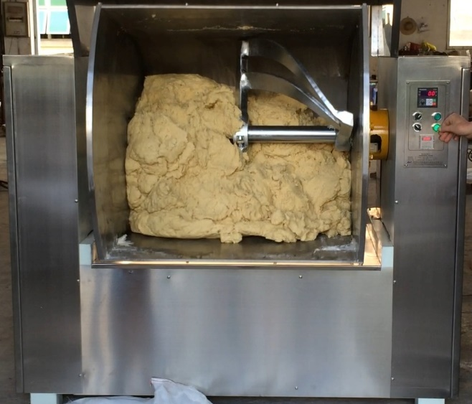After the mixing process the dough unloads to a trolley type container called ‘tub’. Some biscuits recipes required a fermentation of few hours and these dough tubs are sent to the fermentation rooms (with 35 0C controlled temperature) before sending to the tilting end. After the fermentation done, these dough mixer tilts into the cutting area which is in second level.

Figure 2.4:Dough unloading process from the mixer

(Source:https://www.foodsmachine.net/250-horizontal-dough-mixer-for-soft-or-cookie-dough-biscuit.html)

### Sheet forming and cutting process

Normally there are three types of biscuits doughs are being use in the biscuits manufacturing process. Those are soft dough for cookies, fermented hard dough for crackers and non-fermented hard dough for other biscuits types. These three dough types have different types of biscuit forming processes.

#### Soft dough for cookies

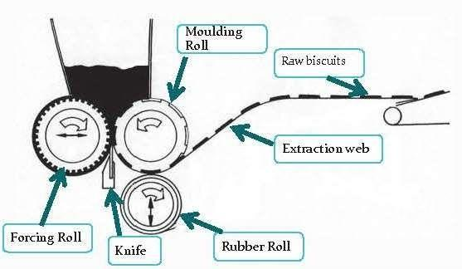Dough sheet forming and molding are the main two steps of biscuits forming process for soft dough. The dough comes from the mixing area is being collected into a tub and using pneumatic controlled forging system and gauge rollers the dough pieces convert into a dough sheet which is having about 1m width and 20mm thickness. Again these sheets drop into a special machine called ‘Rotary Molder’.

Figure 2.5:Configuration of rotary molder

(Source: <https://elektro-boni.de/leistungen/>)

The forcing roll applies the necessary pressure needed to fill the cavity with dough and molding roll has cavities that take the shape of the biscuit. Knife is there to shave the molding roll that makes sure the cavities are filled by the exact amount of dough. Rubber roll is to drive the extraction web canvas and that canvas has the ability to stick out the molded biscuits from the molding roll.

#### Fermented hard dough for crackers and other biscuits

In this type of dough, the sheet forming process is doing by a machine called “Three roller sheeter”. It has 3 large rollers; two are smooth while the last one is grooved in order to facilitate the incorporation of scrap dough. The gap between the smooth rollers can be adjusted by the operator by means of gap adjustment mechanism (pneumatic system). After the sheet is formed it further processes through 4 steps of gauge rollers to reduce the thickness up to 4mm. Then there is a cutter and emboss unit to cut and emboss the sheet into

the shape of the biscuit. The remaining part of the sheet called ‘scrap’ returns into the three-roller sheeter again by returning conveyors.

For crackers, the different is there is a special machine called ‘laminator’ in between three roller sheeter and 1st gauge roller. This unit is used in the preparation of overlaps layers of dough sheets which as a consequence give the flaky appearance and texture to the biscuit. The laying unit receives the dough sheet and cuts it into portions of predetermined lengths. Overlapped dough is received by a lower discharge conveyor and transferred to next gauge roller.

### Baking process

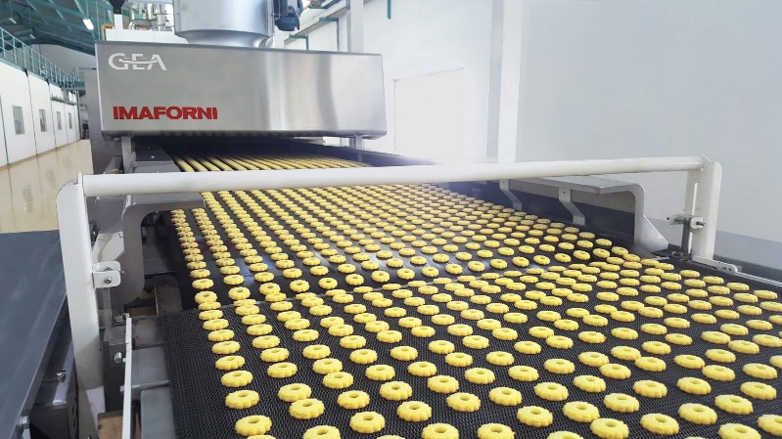

Figure 2.6:Biscuits baking process

(Source: https://www.gea.com/en/products/bakery-equipment/bakery-tunnel-ovens/bakery-gas-ovens/)

Baking is a vital process. Baking is usually take place in an oven consisting of direct gas fired or radiating heating. The conveyor through the oven is made of steel band or wire mesh. In CBL the main energy source for baking process is LP gas. They have 6 plants out of 9 use LP gas. and one plant use electric ovens and one plant use Diesel as the energy source. Following chart shows the dough type and baking energy source of all plants.

Table 1:Energy source of each plant

|  |  |
| --- | --- |
| **Plant** | **Energy source** |
| 1 | Not working |
| 2 | Diesel |
| 3 | Electricity |
| 4 | LP Gas |
| 5 | LP Gas |
| 6 | LP Gas |
| 7 | LP Gas |
| 8 | LP Gas |
| 9 | LP Gas |

### Biscuits Cooling Process

After the baking process baked biscuits need to cool up to the room temperature before it moves to the packing process. And also it helps to reduce the ammonia percentage of the biscuits. In Ceylon Biscuits Limited they are using two types of cooling methods.

#### Forced cooling

In this type of cooling immediately after the baking process there are 4 fan blowers positioned in 1.5m distance apart to supply vertical air flow on the biscuits. It helps to cool the biscuits and reduce the ammonia percentage very quickly. The conveyor distance needed is about 7m to do the whole cooling process.

#### Natural cooling

In this type, after the baking oven there are long conveyors in a zigzag circulating arrangement to give necessary time to cool the biscuits naturally. There are 5 cooling conveyors combined together to form the necessary length of cooling conveyors. Each conveyor has geared motor drive system, tensioning system and automatic pneumatic canvas tracking system. This cooling method used in many plants because the quality of the biscuits which cooled naturally is higher than the foced cooling method.

### Packing section

In this section the stacked biscuits are conveyed through the Packing tables to the Wrapping Machine and then to the packing cartons.

A packing machine consists several electromechanical and pneumatic systems which are controlled by a Programmable Logic Controller. The wrapper in the wrapper real is unwound when the process is running. Then biscuits stacks are gradually wrapped. The Eye mark sensor is used to sense the eye mark printed on the wrapper.

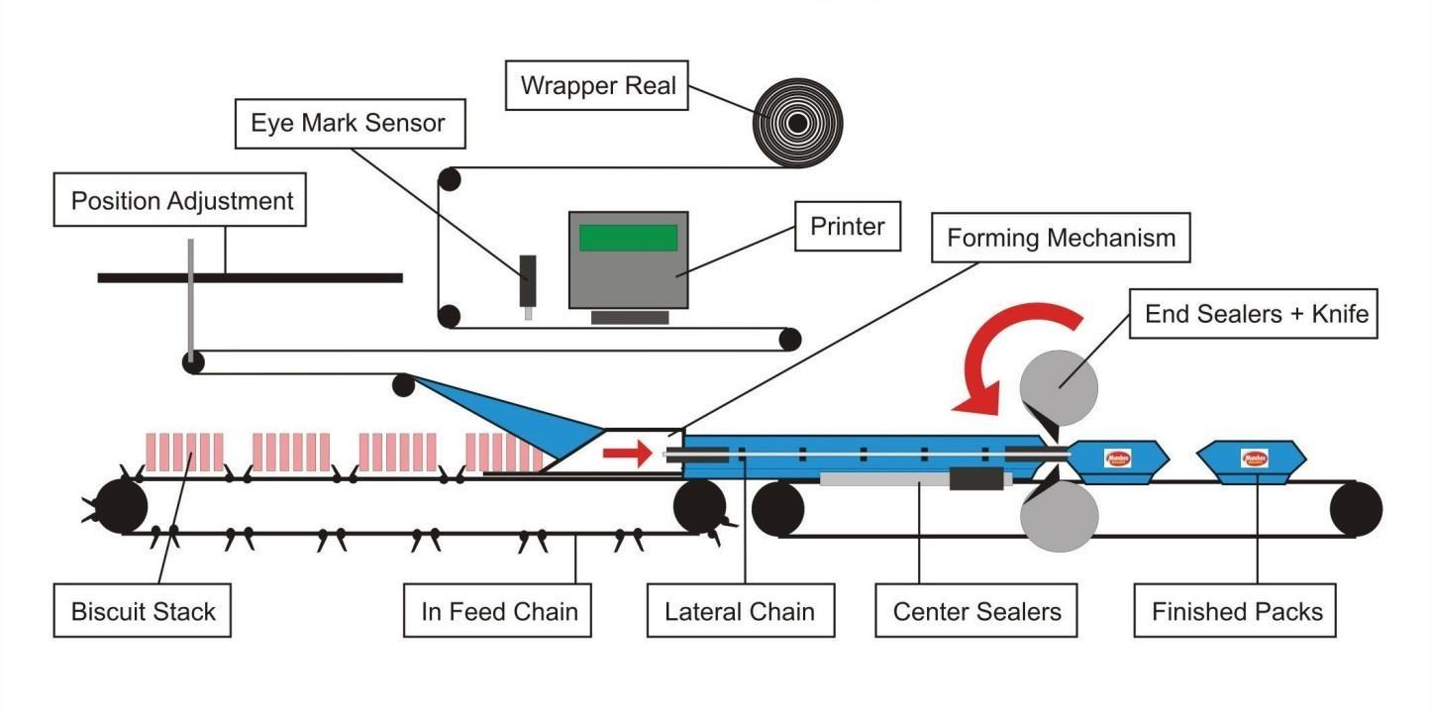The In-feed chain is used to convey biscuit stack to former box. After each stack is wrapped, the Lateral chain conveys the packet of biscuit. The center sealers forms longitudinal sealing of the pack and the end sealers are used to seal end of the pack. And the Knife embedded in this sealer separates finished packets from the wrapper. The final products (biscuits packets) packed and sealed into the cartoons by manually. All these cartoons send into the Finished Goods Stores (FGS)

Figure 2.7:Mechanism of packing machine

## Main Utility Systems

Ceylon Biscuits Limited uses several utility systems for the production process. They are

1. Gas Storing and Distribution system.
2. Compressed air and pneumatic system
3. Compressed air and pneumatic system
4. Chiller system, AHU and FCU units
5. Generator System

### Gas Storing and Distribution system.

Figure 2.8:Gas unloading process

In CBL the LP gas is the main energy source which energizes 6 ovens out of 9 plants. The reason is the energy cost for LP gas is pretty much lower than the other energy sources like electricity, diesel etc. In this kind of large-scale gas consumption factories there is a gas plant which store and supply the LP gas to the operation.

The gas storing and distribution system at Ceylon Biscuits Limited consists of,

* Three gas storing tanks. (25000 liters)
* Three liquid vaporizer machines(600kg,400kg,400kg)
* Regulators.
* Double check filler valves
* Ball valves
* Solenoid valves
* Safety valves
* Pipelines
* Bowser earth point
* Emergency access points

#### Gas unloading procedure from the bowser to the tanks

* Clear the entrance and exit path of gas plant for emergency exit. Bowser safely arises to the plant and stops on the marked area.
* Place few barriers to the tires of the bowser to prevent unexpected movements.
* Connect the earth cable of the vehicle to the plant earth connection to neutralize the electric charge forms when petroleum moving.
* Place the required fire extinguishers on the market places.
* Check the vehicle condition, safety valve operations, filling tank level and its safety conditions by an engineer and approve the unloading process.

#### Gas storing Tanks

Each gas storing tank has a capacity of 25000 liters and operates at a normal pressure of 5.5 bars. These tanks are equipped with three key gauges to measure liquid gas volume, gas pressure, and temperature. We can measure the liquid level in the gas tank in two ways,

* One is a liquid level meter which uses a ball valve to show the liquid percentage of the tank straightly.
* Other one is a manually operated valve which can operate gradually until the very cool (-20 0C) liquid petroleum comes out from it. Then we can get an idea about the liquid level in the tank.

At the bottom of the gas tank there is 3 pipe lines connected. Those are input line of liquid petroleum, output gas line and output liquid line. There is a spring return safety valve connected to the liquid outlet line of the tank. It can open only when compressed air is supplied to it. So, if the compressor does not work or the compressed air line is broken due to a fire or any hazard, that valve will automatically close and stops liquid outgoing.

80% of the tank is filled with liquid petroleum and only 20% is the gas. But the requirement of gas is much higher than that. So, there are few evaporators in the gas plant which converts the liquid into gas and supplies it into the production plant. Sometimes there is liquid petroleum remains in the pipe lines after the loading process and due to the high temperature, it tends to become gas. It causes to increase the pressure inside the pipe line and when it comes to a certain pressure level out feeding valve will open and transfers that extra gas into the tank again. If that valve not operated properly by an error there are pressure relief valves in several places of the pipeline which reduce the danger of blasting a pipeline. There are water lines with nozzles goes around the 3 gas tanks which will supply water on to the surfaces of tanks when there is an unexpected temperature increase in the surrounding area such as big fire.

#### Gas Distribution system

The liquid gas undergoes a transformation into a gaseous state through the liquid vaporizer machines. These machines play a crucial role in converting the stored liquid gas into a usable form by heating it.After the conversion into gas, the pressurized gas is directed through pipelines to the ovens within the factory. This distribution process ensures a seamless and efficient supply of gas to the ovens and the boiler, contributing to the production processes at Ceylon Biscuits Limited. The overall system plays a vital role in supporting the energy needs of the factory, enabling the smooth operation of baking ovens and the boiler.

### Compressed air and pneumatic system

As other industries Ceylon Biscuits Limited is using various type of pneumatic actuators in their machines. To operate those actuators compressed air is used. In here air is compressed to 6 bar and 8 bar pressures. Pneumatic system is consisting with number of components as shown in Figure 2.9. They are,

* Oil injected Rotary screw type air Compressor
* Air Dryer
* Air Filter
* Air reservoir tank
* FRL units
* Pneumatic Actuators
* Pneumatic Solenoid Valve

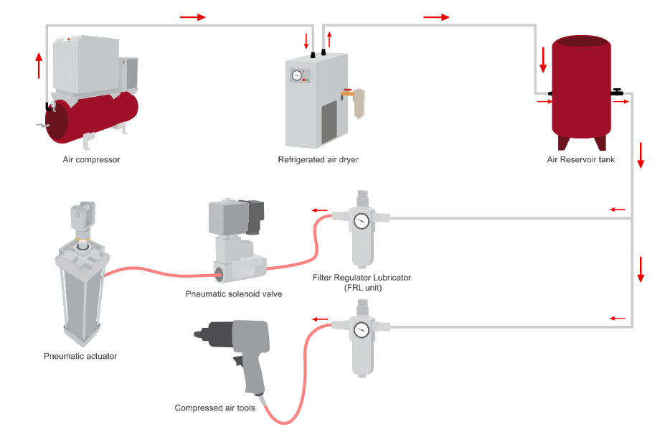

Figure 2.9:Pneumatic system

(Source: https://www.essentracomponents.com/en-gb/)

#### FRL units

Figure 2.10:FRL unit

A Filter/Regulator/Lubricator (FRL) unit is a device used in pneumatic systems to perform three main functions: filtering, regulating, and lubricating compressed air. Compressed air is commonly used to power pneumatic tools, machines, and control systems. The FRL unit helps ensure that the compressed air supplied to these devices is clean, regulated to a consistent pressure, and properly lubricated

#### Pneumatic actuators

Figure 2.11:Pneumatic actuator

Pneumatic actuators are devices that convert compressed air energy into mechanical motion, typically used for controlling or automating various industrial processes. These actuators play a crucial role in pneumatic systems, which rely on compressed air as a power source. The primary purpose of pneumatic actuators is to move or control mechanisms, such as valves, dampers, or other components in machinery.

### Chiller system, AHU and FCU units

An industrial chiller is a refrigeration system that is primarily used to lower the temperature of machinery, industrial spaces, and process fluids by removing heat from the system and transferring it to another location. These systems are particularly useful in applications where maintaining specific operational temperatures is crucial. The Industrial Cooling Chiller System of the Ceylon Biscuits Limited ensures optimal performance and longevity of critical machinery throughout the production process. One of its key functions lies in machine cooling, safeguarding the efficiency of various equipment essential to the manufacturing line. The precision cooling extends to control panels and motors of conveyors, preventing overheating and potential breakdowns that could disrupt production. Post-oven, the Industrial Cooling Chiller System takes center stage in the biscuits cooling process.

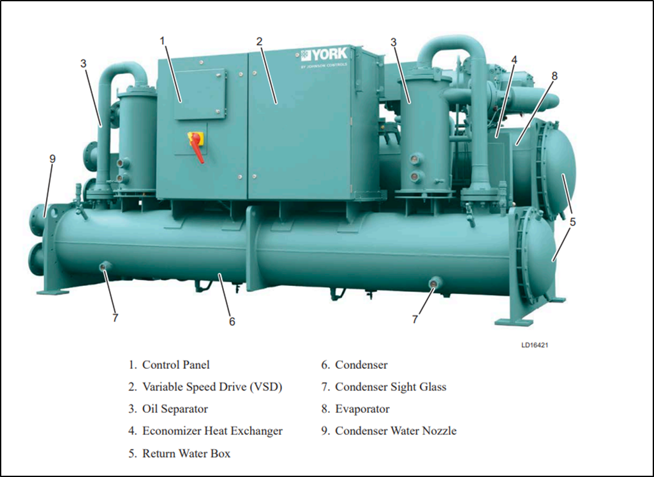By swiftly reducing the temperature of freshly baked biscuits, it not only enhances the product quality but also contributes to the overall efficiency of the production line. Beyond machinery, the system prioritizes the well-being of the workforce by creating comfortable working areas. As it regulates the ambient temperature, laborers can operate in an environment conducive to productivity and safety. Due to higher cooling load, small type AC units can’t be implemented. Therefore, chillers are used. There are two chillers in Ceylon Biscuits Limited reception and factory building.

Figure 2.12:Chiller major components (front view)

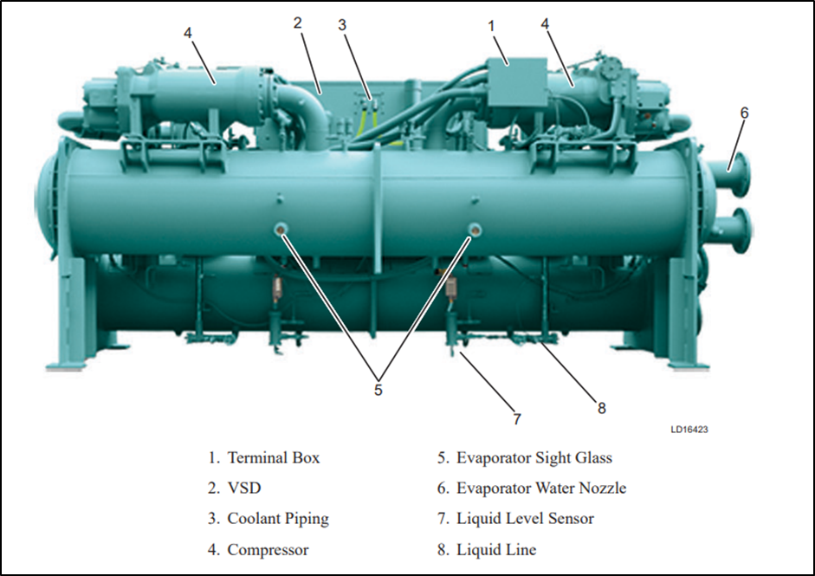

Figure 2.13:Chiller major components (Rear view)

Chiller components main functions are,

* Condenser:

The condenser releases heat absorbed by the refrigerant during the cooling process. It allows the refrigerant to change from a high-pressure gas to a high-pressure liquid by transferring heat to the surrounding environment.

* Compressor:

The compressor is responsible for raising the pressure and temperature of the refrigerant. It compresses the low-pressure, low-temperature vapor from the evaporator to a high-pressure, high-temperature gas, promoting the refrigeration cycle.

* Evaporator:

The evaporator absorbs heat from the surroundings, causing the refrigerant to evaporate and change from a low-pressure liquid to a low-pressure vapor. This process cools the surroundings, such as the air or water circulating through the system.

* Expansion Valves:

Expansion valves control the flow of the refrigerant between the high-pressure side (condenser) and the low-pressure side (evaporator). They regulate the refrigerant's expansion, allowing it to transition from high pressure to low pressure before entering the evaporator.

* Power Unit:

The power unit, which could refer to an electric motor or another source of power, provides the energy needed to drive the compressor. It powers the mechanical components of the chiller system.

* Control Unit:

The control unit manages and regulates the overall operation of the chiller system. It monitors various parameters such as temperature, pressure, and flow rates, and adjusts the components' functions to maintain optimal performance and efficiency.

### Generator system

At Ceylon Biscuits Limited, the backbone of electrical power resilience lies in its four main generators, strategically employed to ensure the uninterrupted operation of the factory and critical processes during power outages. Among these generators are three robust 1000 KVA units and one efficient 823 KW unit, all of which play a crucial role in sustaining the company's production capabilities.

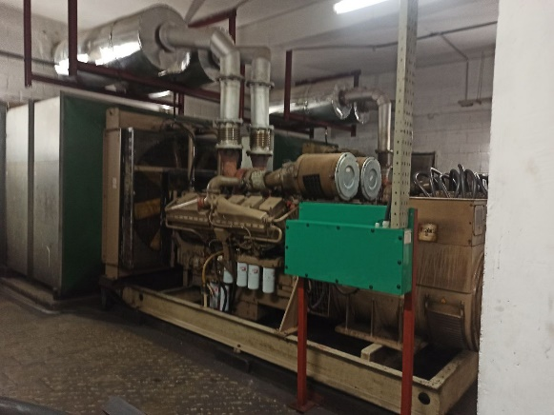

Figure 2.14:Generator (1000kva)

#### Importance of the Generators:

Continuity of Operations:

The primary significance of these generators is to guarantee the continuity of factory operations. In the fast-paced and highly automated environment of Ceylon Biscuits Limited, any disruption in power supply can lead to production downtime, affecting productivity and causing financial losses. The generators act as a reliable backup, instantly kicking in to bridge the gap during power failures.

Process Support:

Beyond the factory floor, these generators are instrumental in supporting various critical processes across the company. From quality control measures to storage facilities, the generators ensure that essential functions continue without interruption. This is particularly crucial in the food industry, where maintaining optimal conditions for production and storage is paramount.

#### Working Mechanism:

* Diesel Engine Power: Each generator is equipped with a powerful diesel compression-ignition engine. This engine is specifically designed to efficiently burn diesel fuel, providing a dependable source of mechanical energy.
* Electric Generator (Alternator): Coupled with the diesel engine is an electric generator, often an alternator. The alternator converts the mechanical energy generated by the diesel engine into electrical energy through electromagnetic induction. This process ensures a stable and consistent supply of electricity.
* Automatic Transfer Switch (ATS): To seamlessly transition from the main power supply to the generators, an Automatic Transfer Switch is employed. In the event of a power failure, the ATS detects the outage and automatically transfers the load to the generators, ensuring a swift response without manual intervention.

## Training Activities – Technical

### Involved in the Bearing replacement process.

Each type of bearing has characteristic properties which make it particularly suitable for certain applications. The main factors to be considered when selecting the correct type are:

* Available space
* Magnitude and direction of load (radial, axial, or combined)
* Speed
* Misalignment
* Mounting and dismounting procedures

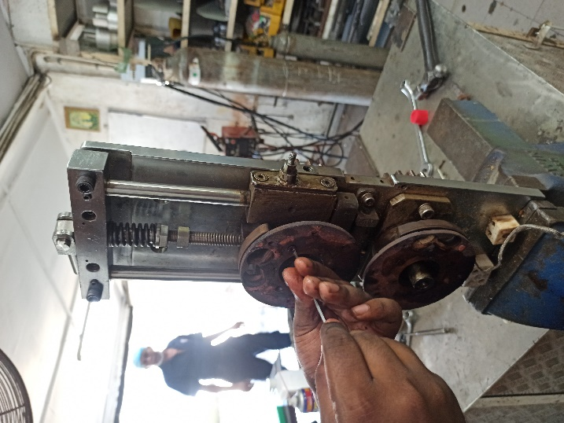

Figure 2.15:Bearing Replacement Process for Center Sealer Unit

#### Bearing replacement process

* Safety Precautions:

Before starting any maintenance work, ensure that the packaging machine is turned off and disconnected from the power source. Use appropriate personal protective equipment (PPE), such as gloves and safety glasses.

* Refer to Machine Manual:

Consult the machine manual or technical documentation for instructions on bearing replacement. Identify the specific type and size of bearings required for the center sealer unit.

* Gather Necessary Tools and Parts:

Collect the required tools, including wrenches, screwdrivers, and a bearing puller.Ensure that you have the replacement bearings on hand.

* Access the Center Sealer Unit:

Remove any covers or guards that provide access to the center sealer unit.Follow proper lockout/tagout procedures to ensure the machine cannot be accidentally powered on.

* Locate and Remove the Existing Bearings:

Identify the location of the bearings in the center sealer unit. Use appropriate tools to remove the bearings, such as a bearing puller. Take note of the orientation of the bearings and any spacers.

* Clean the Bearing Housing:

Clean the bearing housing thoroughly to remove any debris or old lubricant. Inspect the housing for any signs of wear or damage.

* Install the New Bearings:

Apply a small amount of machine-specific lubricant to the new bearings. Carefully install the new bearings into the housing, ensuring they are properly seated. Use a press or other appropriate tools to ensure even and controlled installation.

* Reassemble the Center Sealer Unit:

Reinstall any spacers or other components in the correct order. Put back the covers or guards that were removed earlier.

* Verify Alignment:

Ensure that the newly installed bearings are aligned correctly. Rotate the center sealer manually to confirm smooth operation.

* Test Run:

Power on the machine and conduct a test run without product to verify that the center sealer operates smoothly.

Listen for any unusual noises and check for any issues.

* Adjust and Fine-Tune:

If necessary, adjust the bearing alignment or tension to optimize performance. Follow any specific adjustment procedures outlined in the machine manual.

### Electrical circuit components identification

* MCB (Miniature Circuit Breaker):

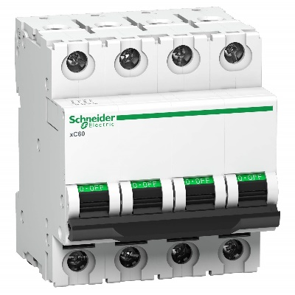MCBs are electrical devices designed to protect an electrical circuit from overcurrent caused by faults or overloads. They are miniature in size and provide a convenient way to manually interrupt the flow of electricity in case of a fault.

Figure 2.16:Miniature Circuit Breaker

(Source: https://cselectric.co.in/blog/difference-mcb-mccb-rccb-elcb/)

* 8-pin Relays:

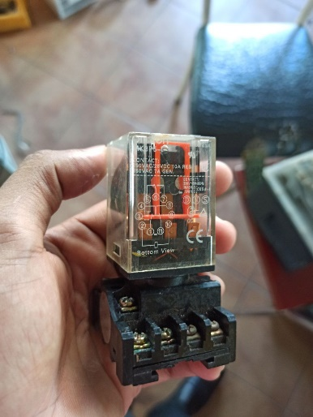An 8-pin relay is an electromagnetic switch that uses an electromagnet to mechanically operate internal switches. The 8 pins typically include a pair for the coil (to generate the electromagnetic field) and the rest for the normally open (NO) and normally closed (NC) contacts.

Figure 2.17: 8-pin Relay

* Contactors:

Contactors are large electrical relays used for switching electric motors and other high-power loads. They have multiple contacts and are capable of handling higher current and voltage levels compared to standard relays.

* 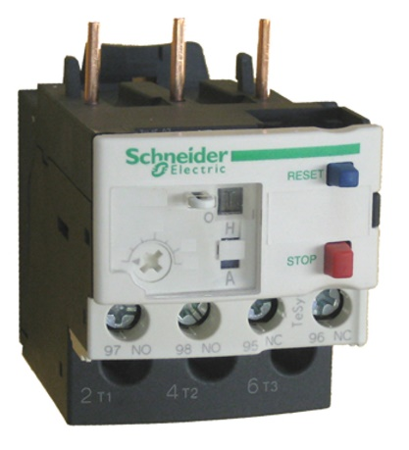Thermal Overload Relays:

Figure 2.18:Thermal Overload Relay

Thermal overload relays are protective devices used to prevent electric motors from overheating. They operate based on the principle of bimetallic strips that bend due to heat, causing the relay to trip and interrupt the current flow when the motor exceeds a specified temperature.

* Solenoid Valves:

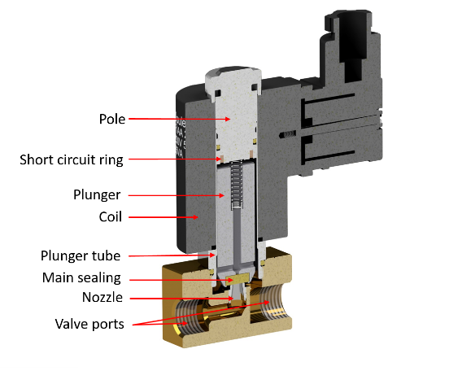Solenoid valves are devices that control the flow of liquids or gases by opening or closing a valve using an electromagnetic solenoid. They are commonly used in various applications such as controlling water flow in plumbing systems, gas flow in heating systems, and more.

Figure 2.19: Solenoid Valve

(Source: https://tameson.com/pages/solenoid-valve-types)

### Involved in the single-phase Motor repairing and rewinding process.

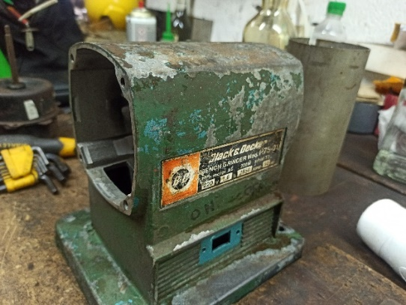Repairing and rewinding a single-phase induction motor involves several steps to restore its functionality. Here is a brief description of the process:

Figure 2.20:single-phase Motor repairing and rewinding process

1. 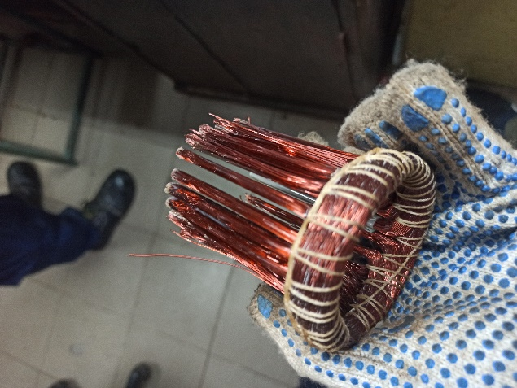Motor Inspection:

Figure 2.21:Single phase motor repairing and rewinding process

Begin by inspecting the motor thoroughly to identify the extent of the damage and the components that need attention. Check for any physical damage, burnt components, or signs of overheating.

1. Disassembly:

Carefully disassemble the motor, documenting the removal of each part. This may include removing the housing, rotor, stator, and other components.

1. Cleaning:

Clean all components, removing dust, dirt, and any contaminants. This ensures a better working environment and helps in identifying hidden issues.

1. Testing:

Perform electrical tests on the windings and other electrical components using instruments like a multimeter. Check for continuity, insulation resistance, and other relevant parameters.

1. Identifying Faults:

Locate and identify the faults in the windings or other components. Common issues include short circuits, open circuits, or damaged insulation.

1. Repair or Replacement:

Repair or replace the faulty components, such as damaged windings or insulation. In some cases, it might be necessary to replace bearings, capacitors, or other electrical parts.

1. Rewinding:

If the motor windings are damaged beyond repair, the motor may need to be rewound. This involves removing the existing winding, calculating the required specifications, and winding new coils.

1. Balancing:

Ensure that the rotor is properly balanced to prevent excessive vibrations and noise. Imbalanced rotors can lead to premature failure.

1. Assembly:

Reassemble the motor, ensuring that all components are correctly placed and secured. Follow the manufacturer's guidelines and use proper torque values for fasteners.

1. Testing and Calibration:

Test the motor under no-load and full-load conditions to ensure it operates within the specified parameters. Make any necessary adjustments and calibrations.

1. Final Inspection:

Conduct a final inspection to verify that all repairs and rewinding have been carried out correctly. Check for any loose connections or potential issues.

### Involved with Three phase motor megger test / Insulation resistance test.

Three-phase motors are used in Ceylon Biscuits Limited industrial plants in different sections. These motors are used to run conveyor belts, pumps, fans, and many other applications. The insulation resistance of motors can gradually deteriorate leading to potential failure.

The causes of insulation failure include:

* electrical stress (current flow)
* mechanical stress (vibrations)
* chemical stress (corrosives)
* thermal stress (heating/cooling)
* environmental contamination (moisture/grime/oil)

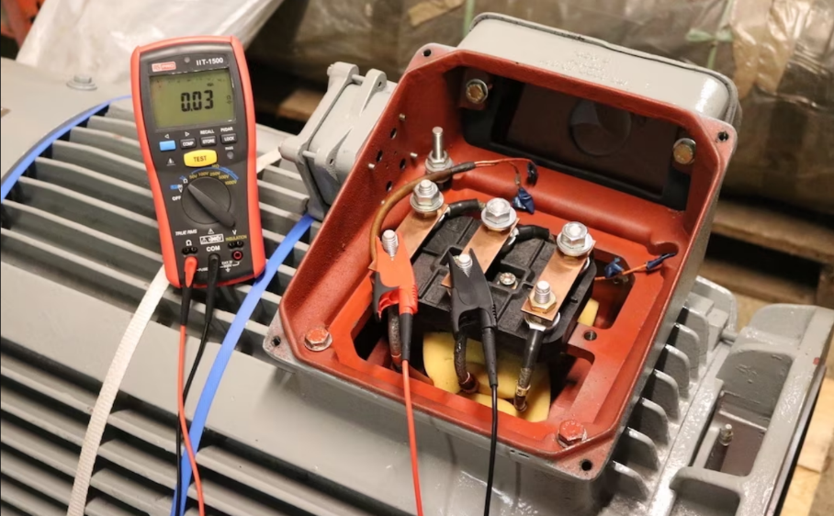Regularly monitoring the insulation resistance of a motor can prove to be a useful method in predicting when it might fail or require maintenance. It's recommended to schedule routine insulation testing with a megohmmeter to ensure maximum motor safety and minimize the risk of electric shock and fire. Insulation resistance testing is an essential part of the maintenance and troubleshooting process for three-phase motors. It helps ensure the integrity of the insulation system within the motor, preventing potential failures and downtime. Here's a general guide on how to perform insulation resistance testing on a three-phase motor:

Figure 2.22:Three phase motor megger test

(Source: https://www.electricalvolt.com/how-to-test-a-three-phase-motor-with-a-megger/)

#### Procedure of the Insulation resistance test

This is accomplished by comparing the resistance between each pair of motor phases as well as the resistance between each motor phase and the frame. Firstly, Clean the insulation surfaces to ensure accurate readings and Connect the megohmmeter to the motor windings.

For three-phase motors, connect one lead to the ground (motor frame) and the other leads to each phase (U, V, W). After that Set the megohmmeter to an appropriate test voltage. The commonly used test voltages are 500V or 1000V.Lower insulation resistance values may indicate potential issues like contamination, moisture, or insulation breakdown. Based on the findings, take appropriate corrective actions, which may include drying the motor, replacing damaged insulation, or conducting further diagnostic tests.

#### Benefits of Insulation Resistance Testing:

* Helps identify potential issues before they lead to motor failure, reducing unplanned downtime.
* Regular testing ensures that the insulation system remains in good condition, contributing to the motor's longevity.
* Early detection of insulation problems enhances the overall reliability of the motor.
* Ensures the safety of personnel and equipment by identifying and addressing potential electrical hazards.

### Three phase Motor control circuits and panel board wiring practice

There are three primary types of starters that are commonly used for starting a squirrel cage induction motor.

* DOL (Direct Online Starter)
* Star Delta Starter
* Soft Starter

#### Practiced DOL (Direct on Line) motor starter circuits

The Direct on Line (DOL) starter is the most basic form of motor starter and is commonly used to start induction motors. With the DOL starter, the stator winding of the induction motor is directly connected to the three-phase supply voltage, resulting in the stator winding receiving the full line voltage. This type of starter is suitable for small-rating motors since, during starting, the motor draws about 6 to 8 times its full-rated current, when the stator winding receives the full-rated voltage.

The circuit diagram for a direct online starter can be separated into two distinct parts.

1. Power Circuit Diagram
2. Control Circuit Diagram

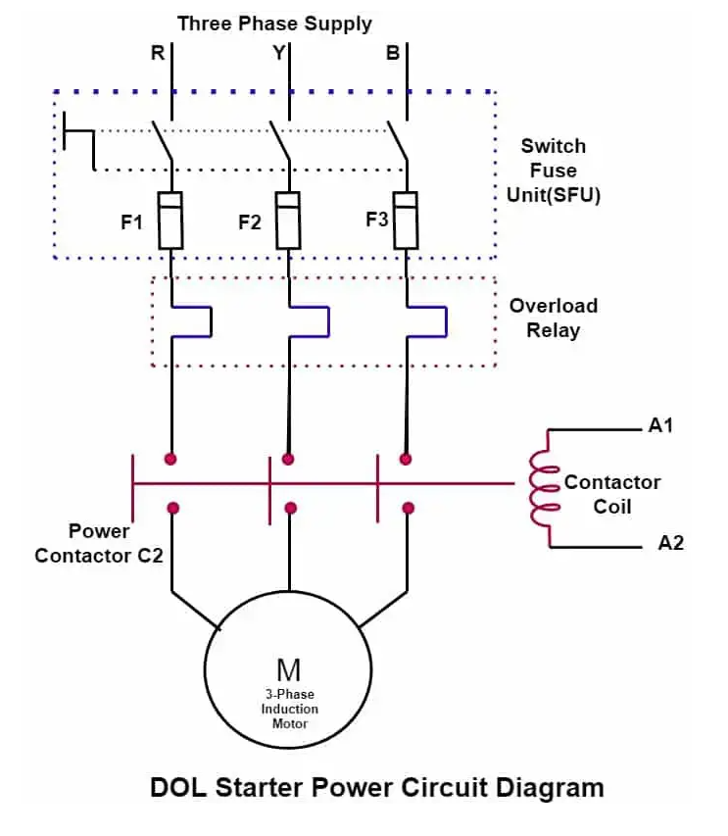1. Power Circuit Diagram

Figure 2.23:Direct On-Line Starter Power Circuit Diagram

(Source: https://www.electricalvolt.com/direct-online-starter-dol-motor-starter-circuit-diagram-and-working-principle/)

The power circuit diagram for a Direct On-Line (DOL) starter typically includes the main components such as the MCCB, Motor Protection Circuit Breaker (MPCB) or overload relay main contractor.

2. Control Circuit Diagram

The control circuit diagram for a Direct On-Line (DOL) starter includes the control components such as, (Start push button, Stop push button, Overload relay, Auxiliary contactor, Indication lamps)

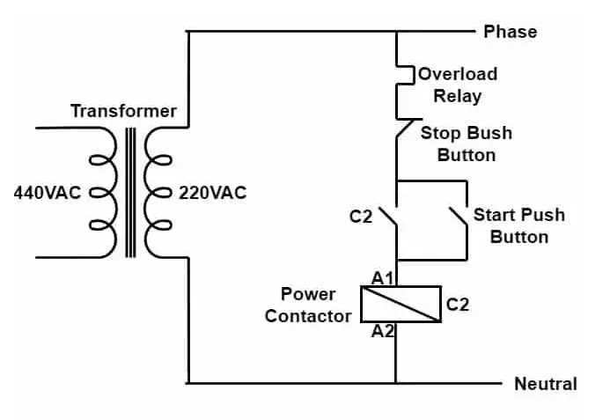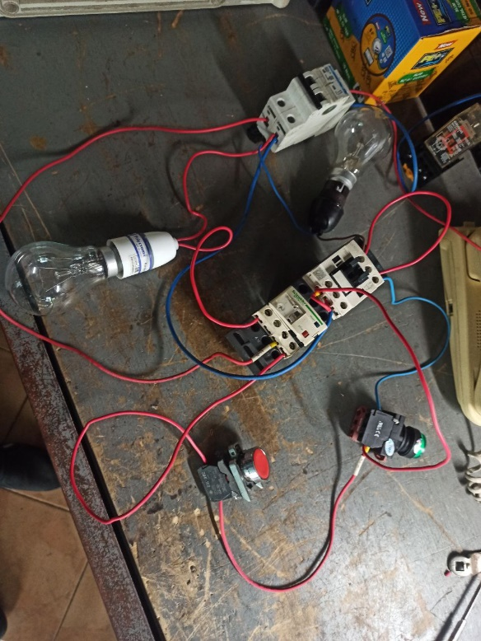

Figure 2.24:Control circuit diagram of DOL starter

(Source: https://www.electricalvolt.com/direct-online-starter-dol-motor-starter-circuit-diagram-and-working-principle/)

Figure 2.25:Control circuit of DOL starter

* Working principle of DOL Starter

When the start push button is pressed, the main contactor C2 (which has an AC3 rating) operates. If the overload relay is functioning properly and the stop push button is not pressed, then the motor receives full voltage and starts running. After the start push button is released, the main contactor C2 remains in the on state due to the holding contact, ensuring a continued supply to the motor stator. To stop the motor, we need to press the stop switch. In case the motor is overloaded and exceeds its rated capacity, the overload relay signals and trips the contactor C2, which in turn causes the motor to stop running.

### Preparing Of an inventory of the packaging machines spares

Maintenance is one of the major activities in industry. Machinery spare parts are playing major role. Problem was mechanical spare parts are critical in machines. The exact model should be used. If not, machines will be malfunctioned.

Therefore, engineering department decided to maintain mechanical component inventory to solve this problem. Packaging machines spare parts in the mechanical workshop were used to prepare this inventory. It was useful for maintenance works to get information about reusable spare parts and facilitate the re-ordering of new spare parts.The task was to create mechanical components list for the packaging machines with all details of them including Brands, model numbers, Capacities, etc. **(Appendix a)**

### Machinery parts designs

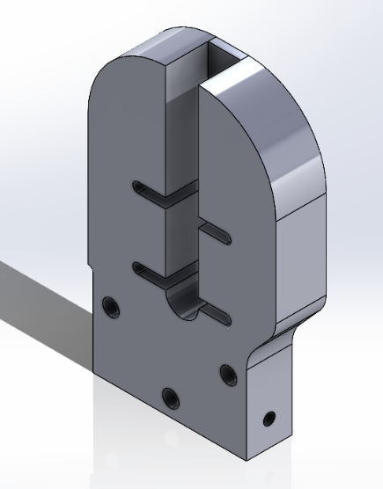3D designs were drawn for fabrication processes of the damaged or crashed machinery parts

Figure 2.26:Oven end cross conveyor part for plant 04

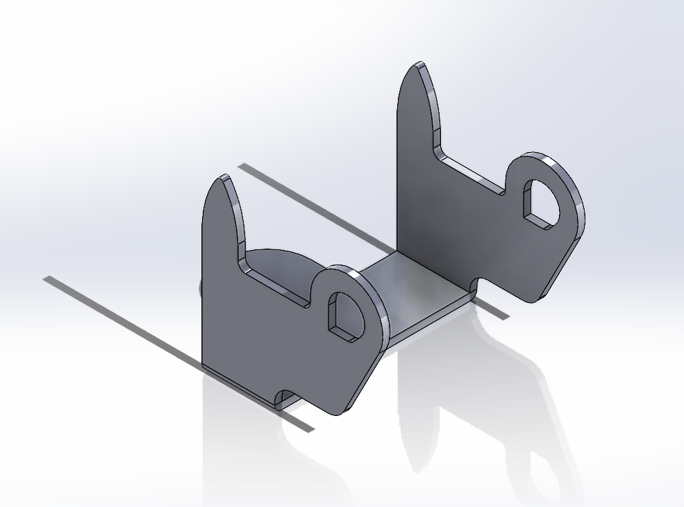

Figure 2.27:Sheet metal machinery part

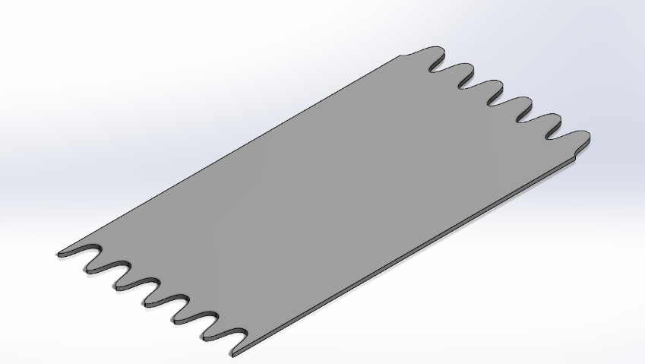

Figure 2.28:Rubber sheet design for a conveyor

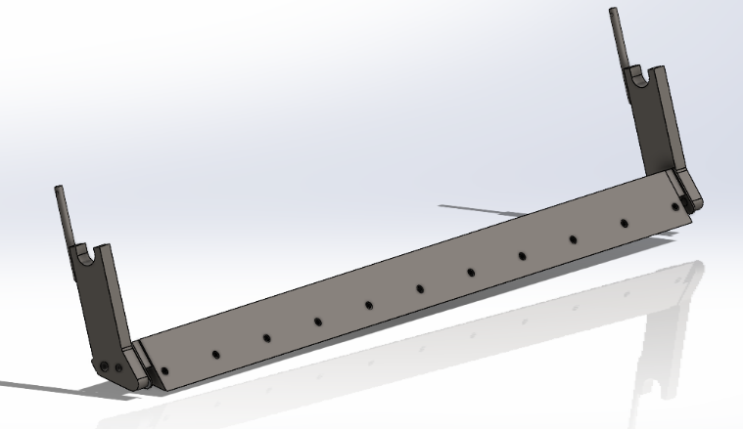

Figure 2.29:Dough cutting knife assembly for plant 02

### Biscuits collecting bins/Hopper designs

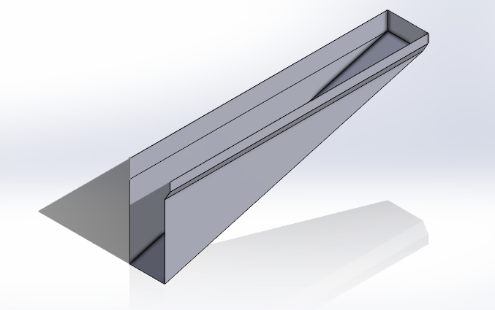

Figure 2.30:Biscuits collecting bin for the plant 09

* 3D design of the Biscuits collecting bin was drawn for the plant 09 FW 151 packaging machine.

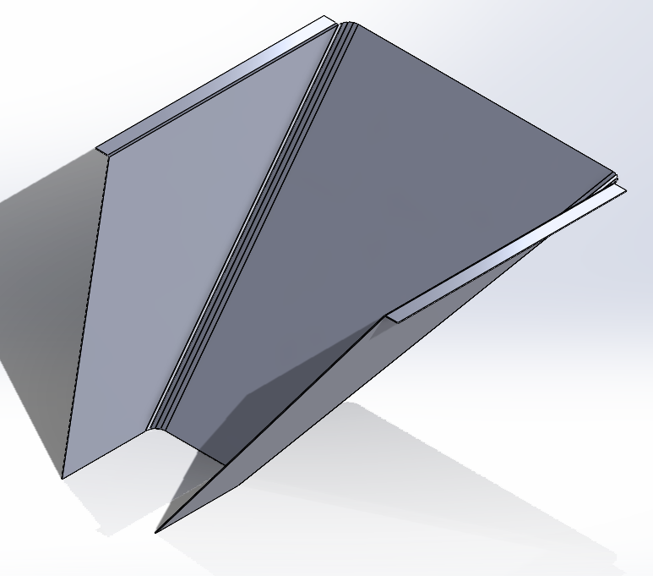

Figure 2.31:Biscuits collecting hopper for the plant 03

* 3D design of the Biscuits collecting hopper was drawn for the plant 03 Seminato Biscuits Biscuits packaging machine.

# CHAPTER 03 – TRAINING EXPERIENCES – MANAGEMENT

## The SHEQ Concept

The SHEQ concept, encompassing Safety, Health, Environment, and Quality. This holistic viewpoint enabled me to contribute to the biscuit factory's commitment to ethical and sustainable production."

**Safety**

* Promoting Safe Practices, I actively participated in safety training sessions to ensure that emergency response protocols, danger identification, and appropriate use of PPE were incorporated into routine operations, emphasizing the importance of safe practices.
* Implementing Risk Assessments: I proactively identified and reduced safety concerns by implementing risk assessments.
* Fostering Continuous Improvement: I advocated for the importance of reporting near misses and safety concerns, fostering a culture of accident prevention and ongoing enhancement.

**Health**

* Ergonomic Workstations: Contributing to the design and implementation of ergonomic workstations, I aimed to minimize the risk of musculoskeletal strain and fatigue among production teams.
* Mental Health Initiatives: Recognizing the significance of mental well-being, I supported the establishment of support systems and initiatives to foster a healthy work-life balance.

**Environment**

* Resource Efficiency: Through investigating and implementing strategies to reduce energy and water consumption, improve waste management, and minimize pollution, I contributed to enhancing resource efficiency across manufacturing phases.
* Sustainable Material Sourcing: I advocated for the use of sustainable ingredients and packaging materials, aiming to reduce our environmental footprint.
* Environmental Compliance: I actively participated in ensuring compliance with relevant environmental regulations and continuously sought opportunities for further improvement.

**Quality**

* Enforcing Quality Control Procedures: I played a role in implementing and monitoring quality control procedures throughout the manufacturing process, ensuring consistent product quality and customer satisfaction.
* Data-Driven Improvement: Leveraging data analysis techniques, I identified quality issues early on and collaborated with teams to implement effective solutions.

## Preventive Maintenance and Condition Monitoring

The training experience involved creating and implementing robust plans for preventive maintenance (PM) and condition-monitoring strategies for various essential utilities in biscuit production. Here, I had to develop a preventive maintenance plan for the ETP plant.

### Effluent Treatment Plant Overview:

Figure 3.1:Effluent Treatment Plant

The Effluent Treatment Plant (ETP) serves as a pivotal component within the biscuits manufacturing factory, efficiently managing wastewater generated throughout the production process. Comprising equalization tanks, aeration systems, anaerobic tanks, and a variety of pumps including submersible and centrifugal types, the ETP system ensures the responsible disposal of effluents while upholding environmental standards.

Despite its importance, the ETP system faced challenges due to deficiencies in existing preventive maintenance (PM) plans. A thorough gap analysis was conducted to identify shortcomings and areas for improvement within the ETP system. This analysis served as the foundation for developing targeted solutions to address the identified issues effectively.

### Condition Monitoring checklist development

Condition monitoring checklist was developed to proactively identify potential issues before they escalate. This system leveraged predictive maintenance techniques and real-time monitoring tools to provide insights into the health and performance of ETP components. By enabling timely interventions and minimizing downtime

### PM Plans Development

Detailed PM plans were formulated for key segments of the ETP system to optimize performance and mitigate the risk of breakdowns. Specific PM plans were developed for critical areas, including:

* + Gully system
  + FOG (Fat, Oil, and Grease) separation system
  + Overall ETP plant

### My Involvements and Contributions:

* I led the formulation and execution of preventive maintenance strategies for the ETP system and also ensured alignment with operational objectives and regulatory requirements.
* Through meticulous planning and implementation, significant improvements were achieved in the reliability and effectiveness of the ETP system, reinforcing its role in environmental stewardship efforts. These plans were designed to enhance operational efficiency and prolong the lifespan of ETP components.

# CHAPTER 04 – PRACTICE OF PROFESSIONAL STANDARDS AND ENGINEERING ETHICS

## Professional standards

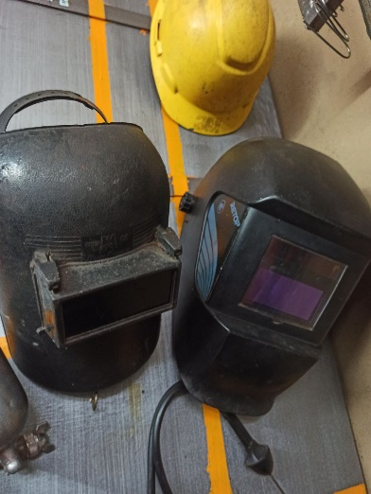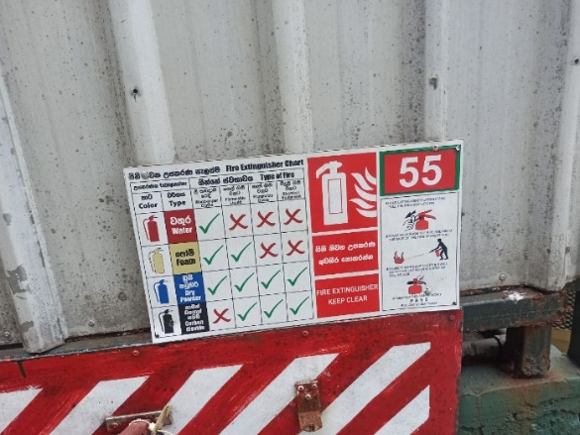Ceylon Biscuits Limited is always maintaining their standards in factory premises. It helps to output quality work. Engineering is always combined with quality of work and standards are playing major role. In any industry health and safety comes first. There is no anything valuable than life. In factory premises also, health and safety become first. All activities are under supervision of health and safety section. Any work carry on factory will be watched by safety officer. Ceylon Biscuits Limited factory premises is organizing several workshops for workers. EHS safety guidelines are followed in factory premises. There are plenty of banners about safety procedures and fire points are in factory premises. Not only inside labors contractors who are hired from outside organizations are also instructed to be safe. They are not allowed to work within factory premises without safety equipment. All of their equipment is checked by safety officer before they start work.

Figure 4.1:Personal Protective Equipment (Welding Gloves)

Figure 4.2:Fire point

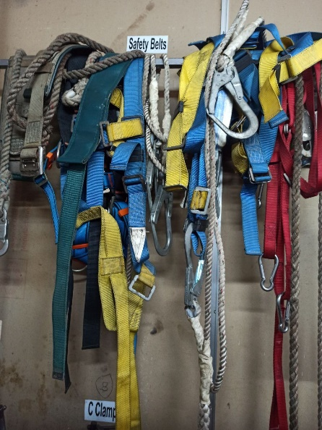

Figure 4.3:Personal Protective Equipment (Safety belts)

## Engineering Ethics

Below are the learnt engineering ethics from this organization.

* Beneficence: Endeavor to do good and avoid causing harm through your work.
* Safety Standards Compliance: prioritize the safety of workers and consumers by adhering to strict safety standards in designing and maintaining machinery and equipment
* Environmental Responsibility**:** Includes implementing energy-efficient processes, reducing waste generation, and ensuring proper disposal of by-products to minimize environmental impact
* Social Responsibility**:** supporting community development initiatives, and addressing social issues through engineering solutions.
* Autonomy: Respect the autonomy of individuals and communities that are affected by your work.
* Justice: Strive for fairness and equity in the distribution of benefits and burdens of your projects.
* Sustainability: Consider the long-term environmental and social impact of your work.

These examples demonstrate how engineering ethics are integrated into various aspects of operations at Ceylon Biscuits Limited, reflecting a commitment to professionalism, integrity, and responsible engineering practices.

CHAPTER 05 – ENVIORNMENTAL AND SUSTAINABILIY

Industrial training is an excellent way to learn about the application of sustainability in the real world. In the training experience at Ceylon Biscuits Limited, a prominent biscuits manufacturing factory, the importance of sustainability in engineering solutions became evident. While working as an engineer in the industry, the major three dimensions of sustainability should all be considered: economy, society, and environment. While economic factors often take precedence, it is imperative to evaluate the broader impacts on the environment and society.

* **Resource Recycling**: CBL implements innovative strategies for resource conservation. For instance, slightly over-baked biscuits are ground into a powder and reused in the production of new biscuits, minimizing waste generation and optimizing resource utilization.
* **Energy Efficiency**: Significant strides have been made towards energy efficiency and pollution reduction. Transitioning from furnace oil to LP gas as the primary energy source for boilers and ovens has substantially decreased harmful emissions. Unlike furnace oil, LP gas combustion produces minimal smoke and dust particles, aligning with environmental sustainability goals.
* **Wastewater Treatment**: Adhering to stringent environmental regulations set forth by the Central Environmental Authority, CBL operates wastewater treatment plants to ensure that industrial effluents undergo thorough treatment before discharge. This commitment to wastewater treatment safeguards the environment and mitigates potential ecological harm.
* **Sustainable Packaging** can reduce waste by switching to biodegradable or compostable materials, reducing packaging size, and implementing recycling programs for used packaging.

Through these initiatives, Ceylon Biscuits Limited exemplifies a commitment to environmental stewardship and sustainable development. By integrating sustainability considerations into engineering solutions, the organization not only fosters environmental preservation but also contributes to the well-being of society at large. This chapter serves to underscore the importance of identifying and addressing sustainability concerns in engineering practices, emphasizing the holistic approach necessary for long-term viability and ethical responsibility.

CHAPTER 06 – SUMMERY AND CONCLUSION